Barber Middle School
Band Uniform Order Form

Dear Parents,

As you are likely aware, the 7th and 8th grade members of the Barber Band wear formal uniforms for all of their performances (on and off campus) in 7th and 8th grade. The Barber Band has a wonderful reputation and it is our belief that all of the musicians should “look as great as they sound.”
These uniforms are purchased at the beginning of the 7th grade year and are worn for their performances until your student graduates from Barber in the 8th grade.
The uniforms consist of a long, black formal dress for the ladies and tuxedo shirts, pants, cummerbunds, and bow ties for the gentlemen. Tuxedos and dresses cost $64.00 and are able to be used through the end of the student’s 8th grade year
Students will be sized by a group of parent volunteers.* If you would like to assist in the uniform process- measuring, hemming, head uniform parent, etc. please contact me via email- Robert.grogan@cobbk12.org

*Once you receive your uniform in September, the hem with need to be altered to the correct length for your student’s height as they do not come in pre-hemmed.

FAQ
How do I pay?
In order to pay for your student’s uniform send a check written out to BARBER MIDDLE SCHOOL with your student’s name and the word ‘uniform’ in the subject area. Your student will obtain a white money envelope and submit the money in to the black money collection boxes found all around the school.

When is the payment due?
Payment is due by FRIDAY SEPT 12th.
Can I pay in installments?
Yes, you may opt to pay in installments with $32.00 due on FRIDAY SEPT 12 and $32.00 due on WEDNESDAY OCT 2.
Is there a way that I may donate to a needy family?
Yes, just add on the amount that you would like to donate. You can indicate this intention on the bottom of the check.
When will I receive the uniform?
Typically uniforms arrive at the beginning of November. Once you receive it, you will need to get it hemmed to the correct length for your student’s height.

Thank You,

Robert Grogan
Robert.grogan@cobbk12.org
770-975-6764 x.2430

ORDER FORM FOUND ON BACK

Band Uniform Order Form

Student Name_______________________________

Parent Name ________________________________

Phone Number _______________________________

Parent Email _________________________________

Grade __________________________________________

PLEASE CHECK ALL THAT APPLY

____ I plan to PAY IN FULL. The $60.00 Uniform fee will be returned by September 12, 2014.

_____ I plan to PAY IN INSTALLMENTS. The first payment of $32.00for uniform will be submitted by September 12, 2014. The second installment of $32.00 on October 1st.

**If a parent has a question regarding payment please email or call me as soon as possible. We are unable to order a uniform for your student if payment has not been set up. This could possibly affect their ability to perform with the group.**

USE A SCHOOL PAYMENT ENVELOPE:
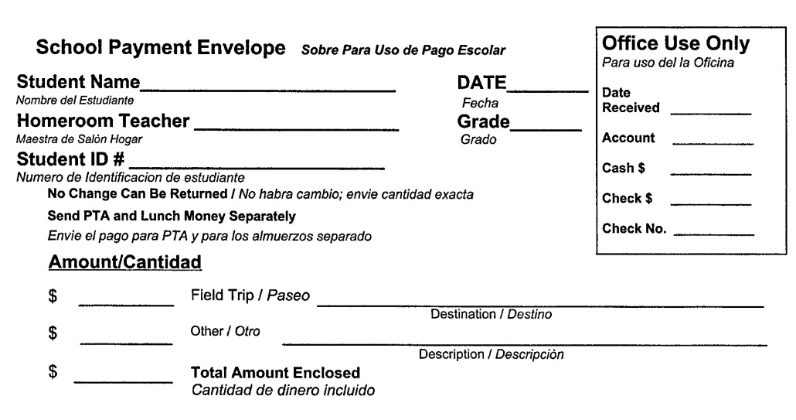

Write “Band Uniform” on the Other line.

